Analysis Summary
Does Wells Dam Overshoot Reduce
Wild Entiat River Steelhead Return?
Public Utility District No. 1 of Douglas County • April 2026

Background
Wild summer steelhead (Oncorhynchus mykiss) returning to the Entiat River must travel upriver past eight mainstem Columbia River hydroelectric dams before reaching their natal tributary confluence. Some fish continue past the Entiat River and ascend Wells Dam’s fish ladders—a behavior known as "overshooting." Wells Dam (rkm 830, owned by Douglas PUD) lies approximately 31 river miles upstream of the Entiat River confluence, so any Entiat-origin fish detected there has definitionally passed its natal stream. This analysis asks:

Do wild Entiat steelhead that interact with Wells Dam have a lower probability of subsequently returning to the Entiat River compared to fish that did not overshoot to Wells?

Upper Columbia River steelhead are ESA-listed as threatened, making this question directly relevant to recovery planning and Wells Dam relicensing obligations.

Data & Approach
PIT-tag detection records for 417 wild Entiat-origin steelhead detected above Rocky Reach Dam (return years 2004–2025) were obtained from PTAGIS. Each fish’s detection history was filtered to retain only post-adult-return detections (using the first Rocky Reach adult fishway detection in July–December as an anchor), and fish were classified into three groups:

Group | n | Definition
A | 239 | No Wells Dam detection after adult Rocky Reach passage
B | 140 | Wells Dam detection post-Rocky Reach; NOT last detected in Methow or Okanogan (strays excluded)
Excluded | 13 | Last detected in Methow or Okanogan — confirmed strays, omitted from analysis

Three Bayesian hierarchical logistic regression models (brms/Stan, R 4.3.2) were fitted with year-level random effects to account for inter-annual variation in return rates:
- Model 1 (all fish, n=379): Entiat return ~ Wells interaction + harvest status + year RE
- Model 1b (all fish): Adds spring return season as a covariate to test for detection efficiency confounding
- Model 2 (Group B only, n=116): Entiat return ~ spring spill hours + fall spill hours + harvest status + year RE

Key Findings

Finding 1: Wells overshoot strongly reduces Entiat return probability

Wells Effect | OR = 0.53 | Group B fish had 47% lower odds of being detected in the Entiat River compared to Group A fish. This effect has posterior probability of 0.997 — essentially certain to be negative.

Group | n | Entiat Detected | Detection Rate
A — Rocky Reach only | 239 | 175 | 73.2%
B — Wells interaction | 140 | 82 | 58.6%
Difference | — | — | −14.6 pp

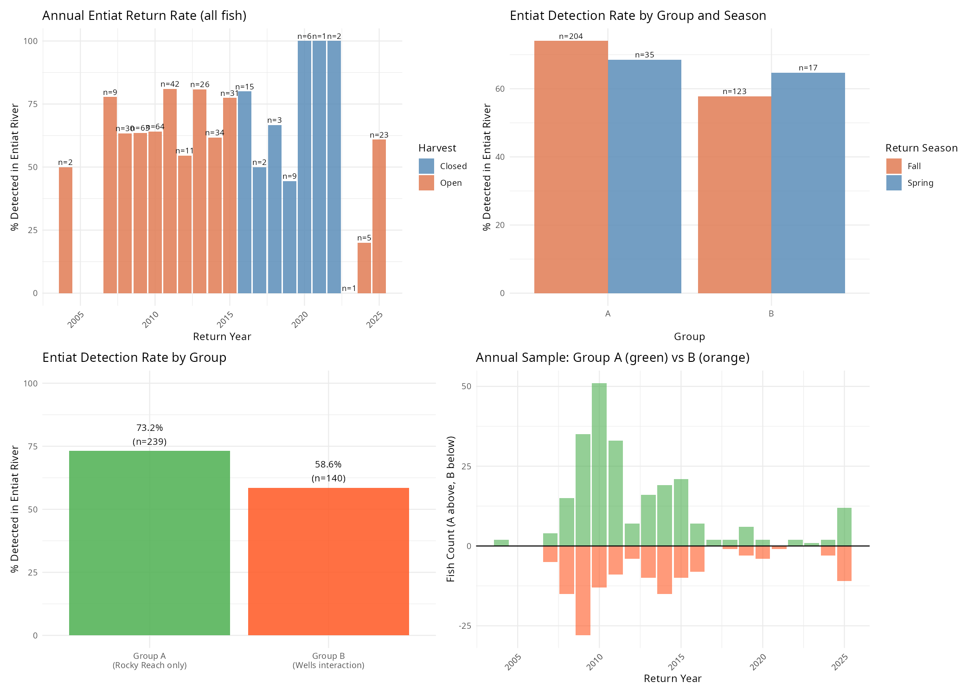

Figure 1. Data overview: annual Entiat return rates (top left), detection rates by group and season (top right), overall group comparison (bottom left), and annual sample sizes (bottom right).

Finding 2: Detection efficiency is NOT the explanation
A key concern was that Group B fish might return in spring when Entiat antenna detection efficiency is lower, creating an apparent—but artifactual—gap. Three independent tests rule this out:

- Group A: 14.6% spring; Group B: 12.1% spring. Seasonal composition is nearly identical.
- fall — when detection is highest. Group A fall: 74.0% vs. Group B fall: 57.7%.
- Adding spring season as a covariate leaves the Wells effect unchanged (OR = 0.52). The season coefficient itself is centered on zero (P(decrease) = 0.53).

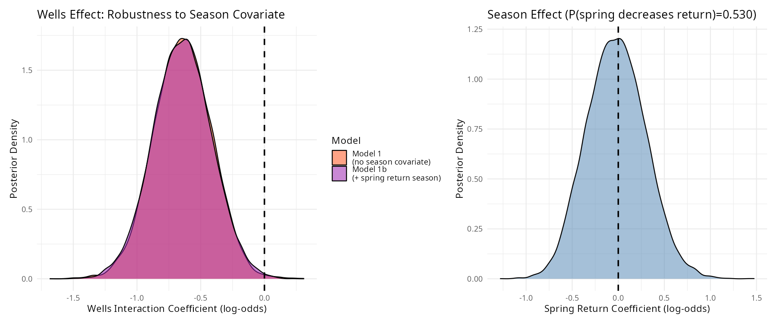

Figure 2. The Wells interaction posterior is virtually unchanged when spring return season is added as a covariate (left), and the season coefficient itself spans zero (right), ruling out detection efficiency as an explanation.

Finding 3: Harvest status has no credible effect

Harvest Effect | OR = 0.79 | 95% HDI spans 1.0 broadly (−1.035 to 0.520). Posterior probability of a negative harvest effect is only 0.72. All fish in this dataset are wild (unclipped), and mark-selective fisheries targeting hatchery fish have no credible direct impact on wild Entiat return rates.

Finding 4: Spill at Wells Dam does not predict Entiat return
Among Group B fish, neither spring nor fall spill hours at Wells Dam predicted whether a fish was subsequently detected in the Entiat River. All Model 2 posteriors are centered near zero:

Parameter | β Mean | HDI Low | HDI High | Odds Ratio
Spring Spill Hours (std) | 0.301 | −0.215 | 0.863 | 1.35
Fall Spill Hours (std) | −0.045 | −0.544 | 0.476 | 0.96
Harvest Open (vs. Closed) | −0.084 | −1.310 | 1.137 | 0.92

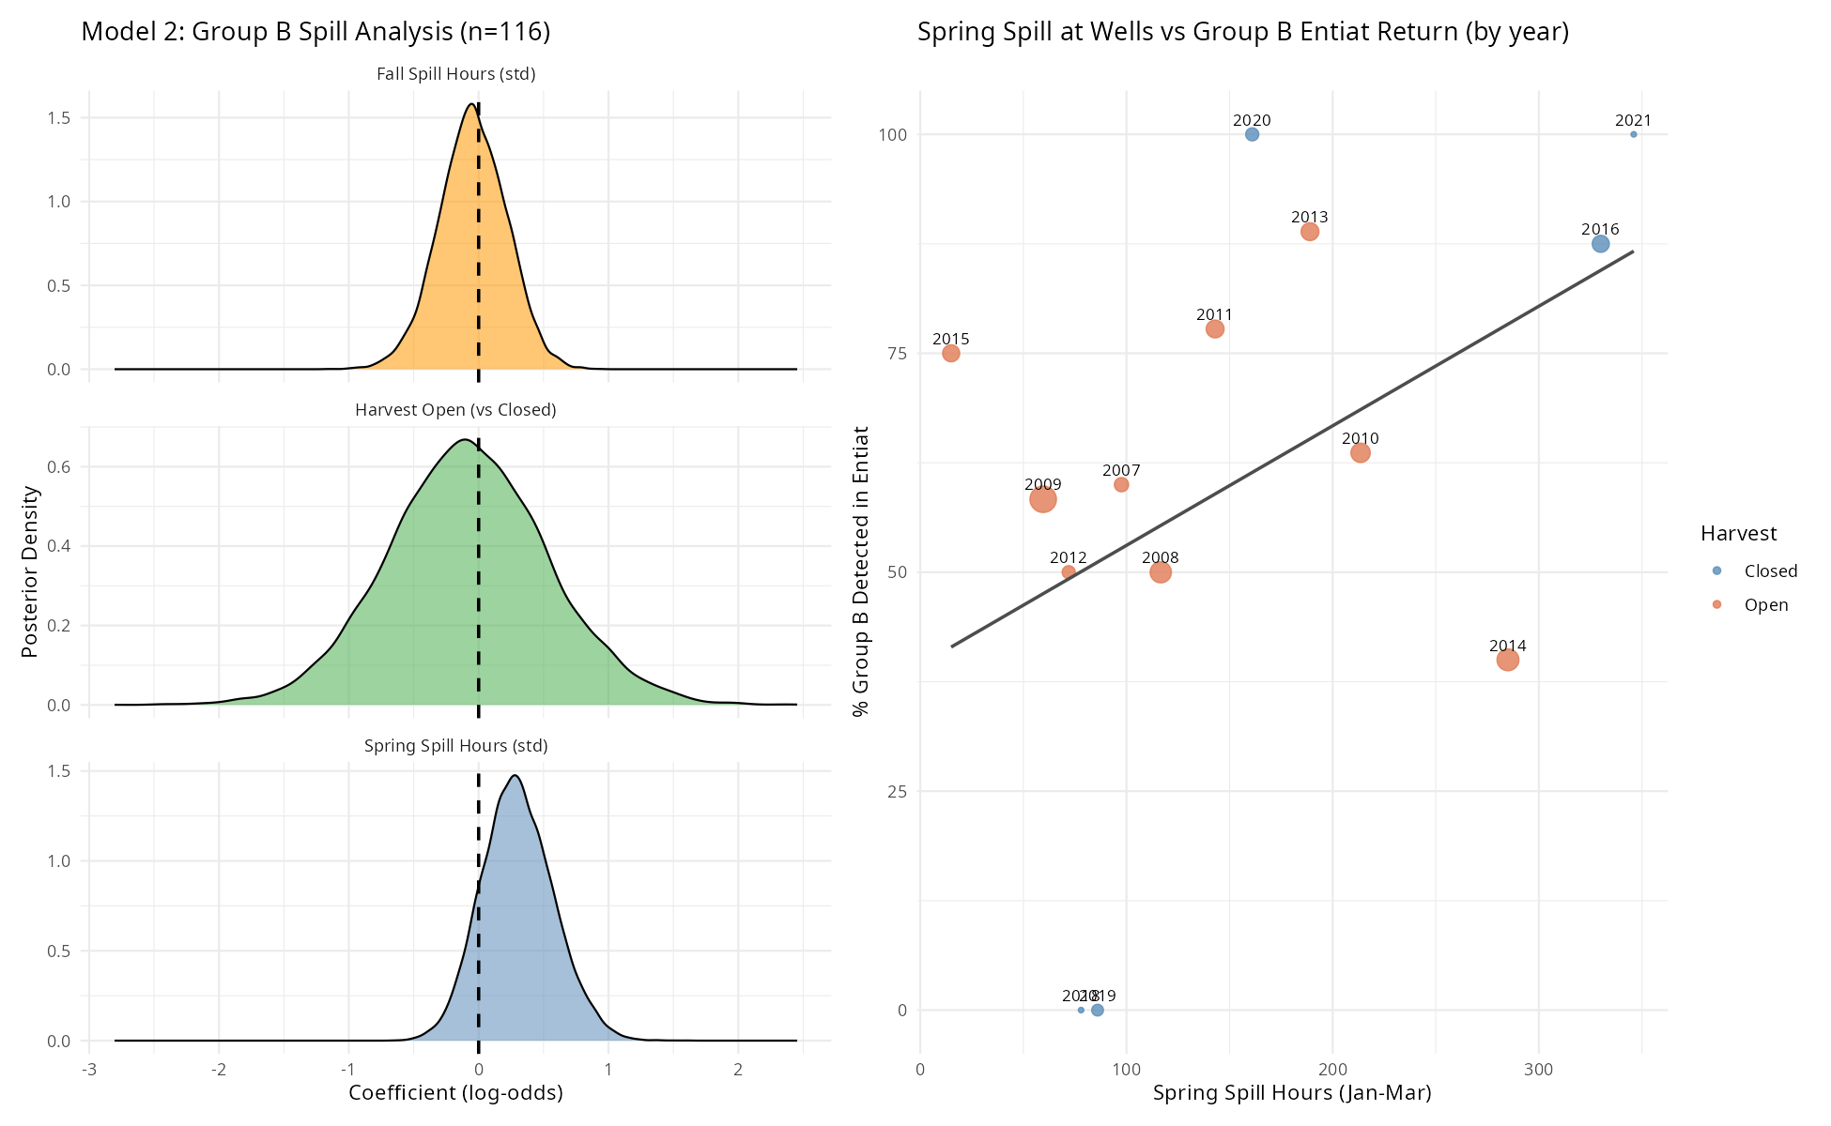

Figure 3. Model 2 (Group B only). Left: All three posteriors span zero. Right: No relationship between spring spill volume at Wells Dam and Entiat return rate in Group B fish.

Complete Model Results

Model / Parameter | β | HDI Low | HDI High | OR | P(decrease) | Sig.
Model 1: All Fish — Wells + Harvest
Wells Interaction | −0.642 | −1.085 | −0.205 | 0.53 | 0.997 | ✓✓✓
Harvest Open | −0.241 | −1.035 | 0.520 | 0.79 | 0.724 | —
Model 1b: All Fish — Wells + Harvest + Season
Wells Interaction | −0.645 | −1.083 | −0.184 | 0.52 | 0.998 | ✓✓✓
Spring Return Season | −0.021 | −0.634 | 0.594 | 0.98 | 0.530 | —
Model 2: Group B Only — Spill Effects
Spring Spill Hours (std) | 0.301 | −0.215 | 0.863 | 1.35 | 0.136 | —
Fall Spill Hours (std) | −0.045 | −0.544 | 0.476 | 0.96 | 0.574 | —
Harvest Open | −0.084 | −1.310 | 1.137 | 0.92 | 0.561 | —

✓✓✓ = P(decrease) ≥ 0.99 (strong evidence for negative effect). — = no credible directional effect (95% HDI spans zero). OR = odds ratio. All models used weakly informative Normal(0,1) priors on fixed effects, Normal(0,2) on intercept, 4,500 MCMC iterations, 4 chains; all R̂ ≤1.01.

Interpretation
The Wells Dam interaction effect is the clearest and most robust finding from this analysis. The 14.6 percentage-point raw gap in Entiat detection rates translates to a Bayesian odds ratio of 0.53 that holds up across every modeling approach tested. What are the likely biological explanations?

- incomplete strays — they entered the Methow or Okanogan without being detected at known sites, bypassing the stray exclusion criterion.
- fail downstream passage at Wells Dam — difficulty navigating spillways or injury from turbine passage could prevent return to the Entiat.
- die before reaching the Entiat — overwinter mortality in reservoir-holding fish, thermal stress, or predation between Wells and the Entiat confluence.
- returned to the Entiat but were missed by all antennas — ENL miss rates (~8% fall, ~24% spring) mean some true returners would be undetected.

The fact that spill operations and harvest status do not predict this effect within Group B fish suggests the Wells Dam interaction itself—not the conditions at the dam at any particular time—is the relevant factor. Whether overshoot is the cause of reduced return or a symptom of the same behavioral state that leads to non-return cannot be determined from PIT-tag data alone.

Management Implications
- substantially lower Entiat return rates following Wells Dam interaction. Across the 140 Group B fish, the Wells effect translates to approximately 58 fewer Entiat detections than expected at Group A return rates.
- (fall or spring) are unlikely to meaningfully improve wild Entiat return rates based on these data, consistent with recent Columbia Basin findings (Min et al. 2025).
- no detectable direct effect on wild Entiat steelhead return rates in this dataset, consistent with the expectation that unclipped fish are not directly targeted.
- unmeasured factors — potentially temperature, flow, or fish condition — influence annual return rates and warrant further investigation.
- tracking individual wild Entiat fish above Wells Dam would help distinguish passage failure, stray behavior, and overwinter mortality as contributing mechanisms.

Full statistical methods, model diagnostics, and complete results are available in the companion manuscript:
Entiat_Wild_Steelhead_Wells_Overshoot_Manuscript.docx

Analysis code: entiat_return_bayesian_analysis.R (Entiat Wild folder).

